

***Internship (3 month, 6 month, year around)*** – The position reports to the Golf Course Superintendent, First Assistant Superintendent, and Second Assistant Superintendent. The position will entail all aspects of golf course management. This includes entry level experience as well as advanced such as, fertilizer and pesticide applications, projects, management, organization, record keeping, and detail. This will be a great opportunity for a student to hone their skills in all facets of golf course management and landscaping. These skills include agronomy, economics, management, construction, efficiency and detail. This will also be a great chance for the individual to experience Honours Golf/Troon Management as well as, individual ownership.

Peninsula has a great track record of preparing and training individuals allowing them to advance in the golf industry. Furthermore, successful internships have been rewarded with management positions at Peninsula, within Honours Golf, as well as outside of the Troon network. Interns are given the constant support and resources needed to ensure their professional growth.

Our goal is to successfully prepare interns for an AIT/ Second Assistant Superintendent position.

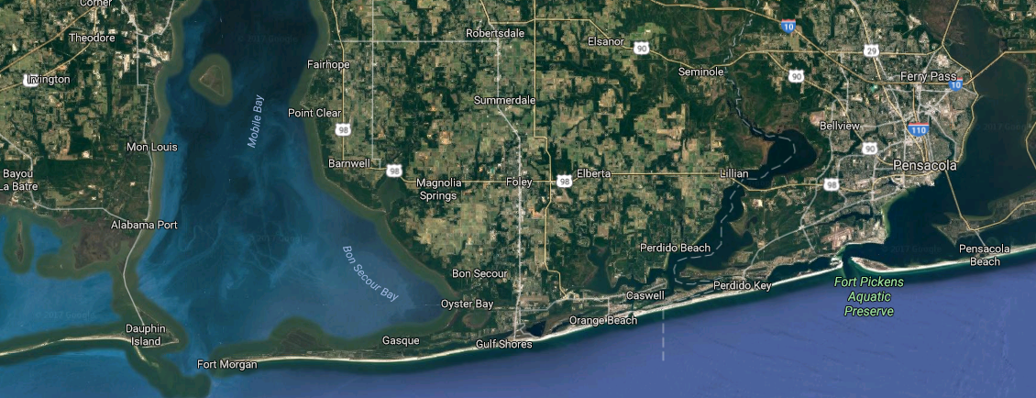

Pay range: $10.00/ hr + OT

Benefits will include: **Housing**, uniforms, discounted meals, golfing privileges, travel and expenses paid for tournament volunteer, overtime, etc…

Peninsula is an 800+ acre community adjacent to the Bon Secour Wild Life Refuge. The club includes a 27 hole golf club, swim & tennis club, restaurant, as well as gym and spa.

Please forward resumes to:

Mr. Jamey Davis, CGCS

Peninsula Golf & Racquet Club

20 Peninsula Boulevard

Gulf Shores, AL 36542

251-968-8001

[Jamey.davis@honoursgolf.com](mailto:Jamey.davis@honoursgolf.com)

